PRESS RELEASE
COMMUNICATIONS AND MEDIA TEAM OF THE 43RD ASEAN SUMMIT 2023
No. 35/SP/TKM-ASEAN2023/ENG/9/2023

Revitalized TMII to Host 43rd ASEAN Summit Spouse Program
Jakarta, 2 September 2023 – Taman Mini Indonesia Indah (TMII) is ready to host the Spouse Program of the 43rd ASEAN Summit on Wednesday (6 September 2023). This is a special event for the spouses of the heads of state of ASEAN member states and constitutes a part of the 43rd ASEAN Summit in Jakarta.
TMII has undergone renovations, carried out by the government in collaboration with PT Injourney, a state-owned enterprise, making it better-organized, greener, more beautiful, and more comfortable.
“Now, people can visit and enjoy the new face of TMII. The revitalization has made TMII better,” said Indonesian President Joko Widodo, marking the completion of TMII’s revitalization in Jakarta on Friday (1 September 2023) evening.
The revitalization areas include 7.71 hectares of building renovation and 26.56 hectares of TMII’s overall area. Renovations encompassed four zones, with the front area being the first zone. The other zones are the Archipelago Lake, traditional house pavilions, and the modernization of museums. The Garuda Theater and Keong Mas Theater were rebuilt to keep up with the times.
The president said that the revitalization restored the original spirit of the development of TMII according to the main plan. Currently, 70% of the TMII area is open space with only 30% consisting of buildings.
“All museums and regional pavilions have also been beautified and revitalized along inclusive, cultural, and smart concepts. I am confident that with its new look, TMII will be a great tourism icon in Jakarta, and of course, in Indonesia,” said the Head of State.

Philosophy of the New Face of TMII
The revitalization of TMII has been carried out since 2022 with a budget of Rp1.070 trillion from the central government and Rp200 billion from PT Injourney.
Minister of State-Owned Enterprises Erick Thohir stated that the new face of TMII embraces several philosophies. The first one is inclusivity while upholding the strength of the nation, Pancasila.
TMII is presented as a tourist destination that is open to all layers of society with tolerance and respect for each other’s culture.
Green philosophy is also applied in the TMII area through a policy promoting the use of electric vehicles and environmentally friendly energy sources.
“We have preserved 70% of TMII as green space. We also use electric vehicles,” Thohir said.
The next philosophy adopted by TMII is intelligence through the implementation of digital platforms, representing Indonesia in the future.
“We can see the modernity of our nation, where everything is technology-driven. We start with ticketing, and there will be a fully digital views later,” said the minister.
The last one is the cultural philosophy where TMII becomes a tourist destination that represents the diversity of Indonesian cultures.
This philosophy is realized through the optimization of artistic and cultural activities as well as various attractions on open stages, allowing visitors the opportunity to witness live artistic and cultural performances and become a part of the culture themselves.
“This is what we present. Hopefully, we can continue its maintenance, not just the construction,” he said.
The revitalization project of the new face of TMII, which began in January 2022, was carried out through collaboration between the Ministry of State Secretariat, the Ministry of Public Works and Public Housing, and the Ministry of State-Owned Enterprises.
Improvements have been made to area roads, pedestrian pathways, landscaping, drainage, and the main gate. Today, the main gate is more organized and comfortable. Several parking lots are provided for visitors. Visitors can use environmentally friendly vehicles to explore and enjoy the green area of TMII.
TMII's icon, the Archipelago Lake, is a lake adorned with miniature islands representing the various islands of Indonesia. The lake is now equipped with a dancing fountain that showcases a light show in the evening. The dancing fountain show is held every evening on the lake.
The Spouse Program of the 43rd ASEAN Summit is scheduled to be held at Sasono Utomo building and the Archipelago Lake. The spouses will enjoy various events, including an opening dance, short film screenings, as well as an exhibition of micro, small, and medium enterprises (UMKM). The event will conclude with the spouses having lunch together. (Toro/Diana/TR/Elvira/WW)
***
For more information, please contact:
Director General of Public Information and Communications of the Ministry of Communications and Informatics – Usman Kansong (0816785320).
Get more information at http://asean2023.id, https://infopublik.id/kategori/asean-2023, and https://indonesia.go.id/kategori/ragam-asean-2023

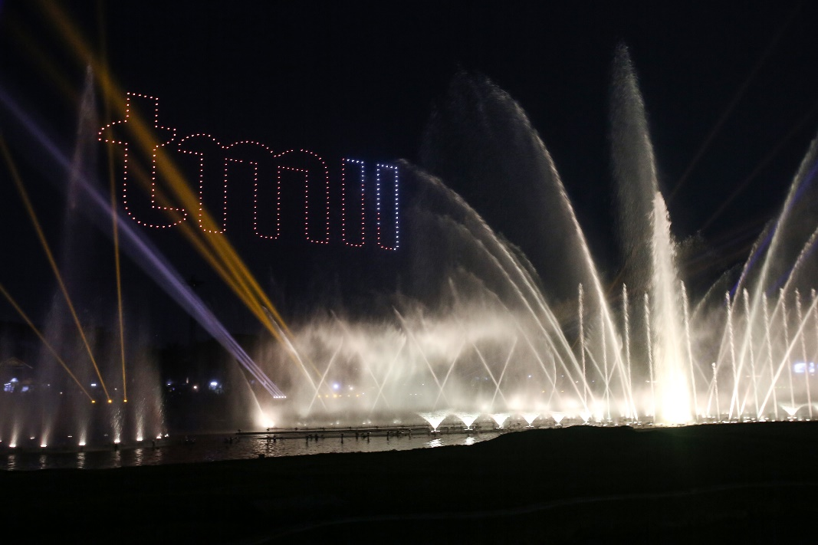
A drone show spelling out “TMII” and the dancing fountain performance at the Archipelago Lake, Taman Mini Indonesia Indah (TMII) Jakarta, on Friday (1 September 2023). The unveiling event of TMII’s new face post-revitalization features a contemporary design and a variety of dancing fountain attractions that combine water screen technology, lighting, and three hundred drones. ANTARA FOTO/Asprilla Dwi Adha/hp.

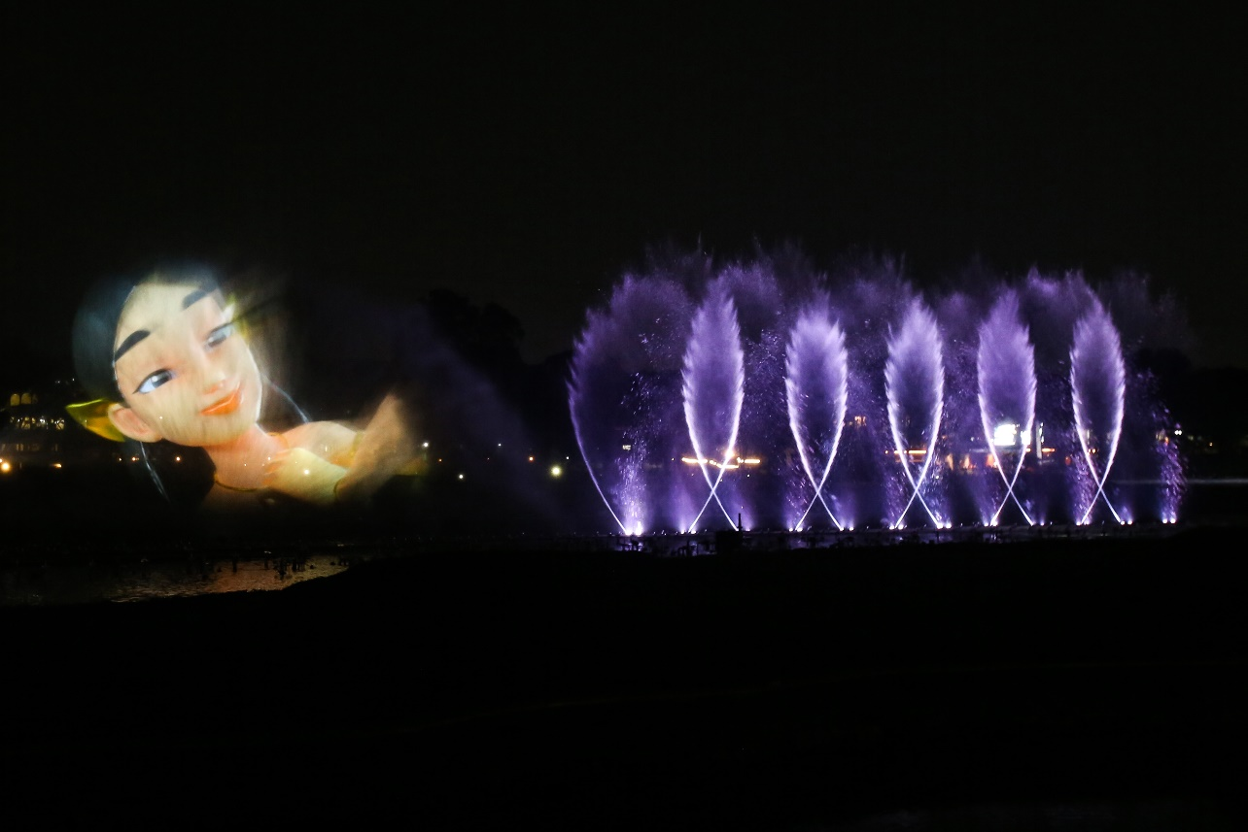

The video mapping performance on the fountain during the unveiling event of Taman Mini Indonesia Indah (TMII) new face at the Archipelago Lake, TMII Jakarta, on Friday (1 September 2023). The unveiling event of TMII’s new face post-revitalization features a contemporary design and a variety of dancing fountain attractions that combine water screen technology, lighting, and three hundred drones. ANTARA FOTO/Asprilla Dwi Adha/hp
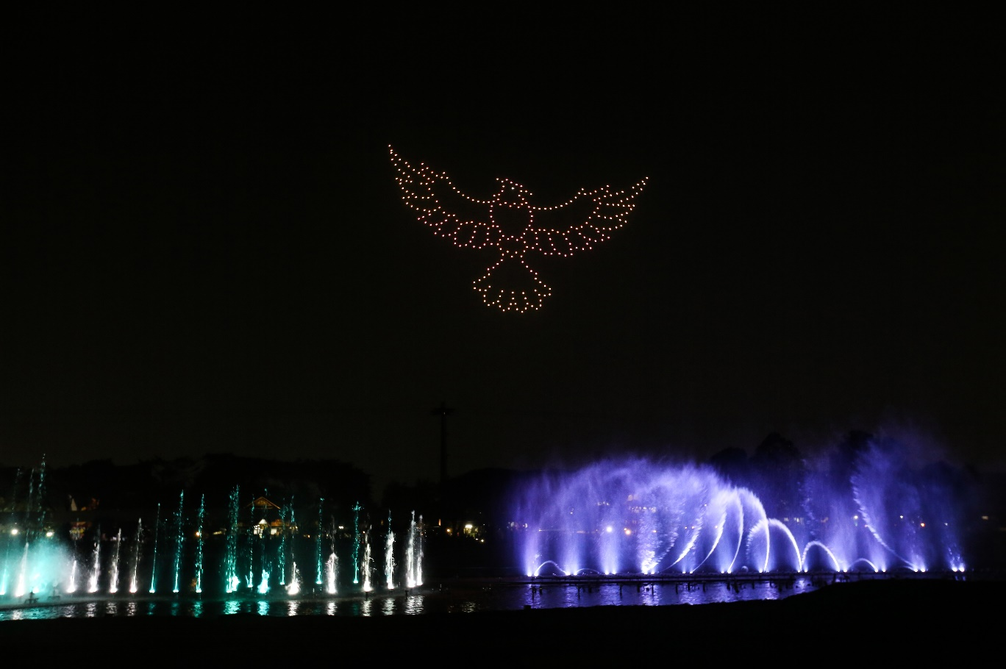

A drone show with the formation forming a ‘Garuda’ bird and a dancing fountain performance during the unveiling event of Taman Mini Indonesia Indah (TMII) new face at the Archipelago Lake, Taman Mini Indonesia Indah (TMII) Jakarta, on Friday (1 September 2023). The unveiling event of TMII’s new face post-revitalization features a contemporary design and a variety of dancing fountain attractions that combine water screen technology, lighting, and three hundred drones. ANTARA FOTO/Asprilla Dwi Adha/hp.

